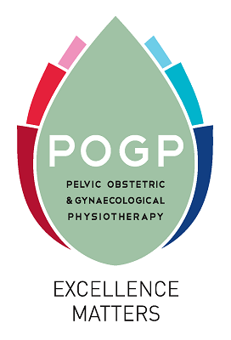
Application for funding from the Dame Josephine Barnes Bursary

- Closing dates: 31 January or 31 July each year
- Please answer ALL the following questions

- Please give details of the course that you are applying for. Or, if the application is to present a research poster or give a presentation, please attach a proposal including title, brief abstract of project, background and purpose and details of conference meeting

- Please state the relevance of this project to pelvic health including the proposed benefit to both the patient and the organisation POGP

- Please show evidence of commitment to completing proposed course and reasons why POGP should consider your application – how relevant is this to your career development and future CPD?

- Please itemize anticipated expenses:

COURSE | Amount
Course Fees
Travel
Subsistence
Amount requested

- Have you sought funding from POGP before? If yes, please specify when, amount and for what funding was received.

Please return the following completed forms to awards@thepogp.co.uk:

- POGP Registration form for Bursaries, awards and prizes
- Application form
(THIS MUST BE ANONYMISED)
- Curriculum Vitae (ANONYMISED)
- Any other relevant information

